

I’ve been eating oysters at Bill’s oyster bar pretty much my entire life. My dad used to bring my sister and me to the farmers’ market in Los Gatos. At eighteen months old, or so the story goes, he gave us a chance to have our first oyster. Expecting we might not like them or, at most, like the ocean water taste, he was surprised to have us both look up with empty oyster shells in hand saying, “More?” That was only the beginning of a long string of Sunday mornings and oysters on the half shell.

One of my best childhood memories is of Bill’s bar. When my sister and I were about 9 years old, we ran a 5K at Nisene Marks with a school group. After the race, we went to see Bill at the Cabrillo Farmers Market and he said we could have all the oysters we wanted as a celebration of the race. I won’t say how many we ate, but it was enough that I can imagine Bill regretted his “all you can eat” statement.

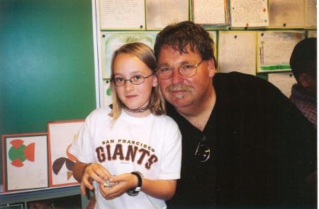

A couple of years ago, I decided to put my extensive knowledge of oysters to good use and started working the bar as an assistant for Bill and my dad. After a few events, I was deemed fit to work parties solo. When I show up to a gig, people are sometimes shocked to see a young, relatively delicate looking female schlepping gear and cracking shells. But don’t let my looks fool you, I’m a tough mothershucker.

When I’m not working the bar, I fill my time nannying, coaching high school girls’ basketball, and studying to be an elementary school teacher.